**How to Set Up the Jenkins + GitHub Integration**

**Step 1:** go to your GitHub repository and click on **‘Settings’**.

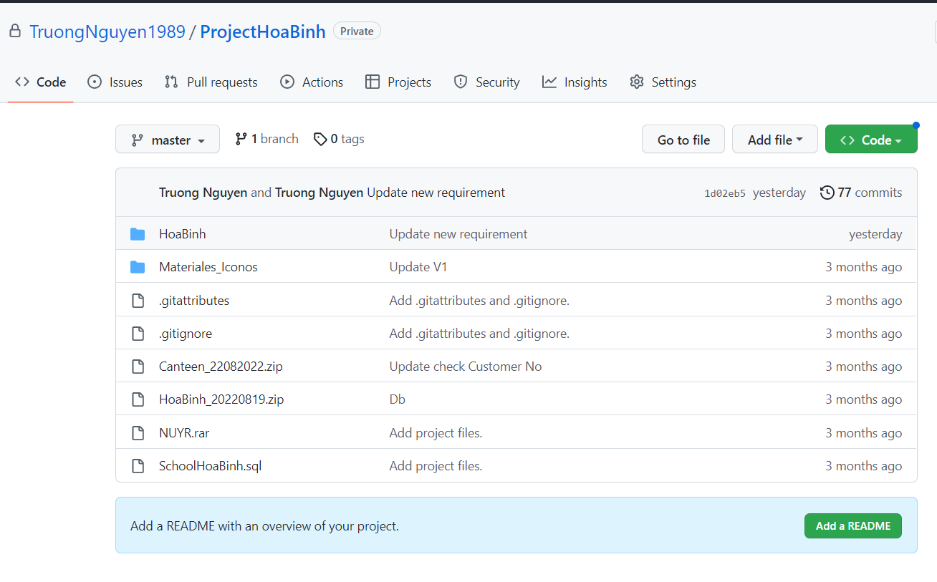

**Step 2:** Click on **Webhooks** and then click on ‘**Add webhook**’.

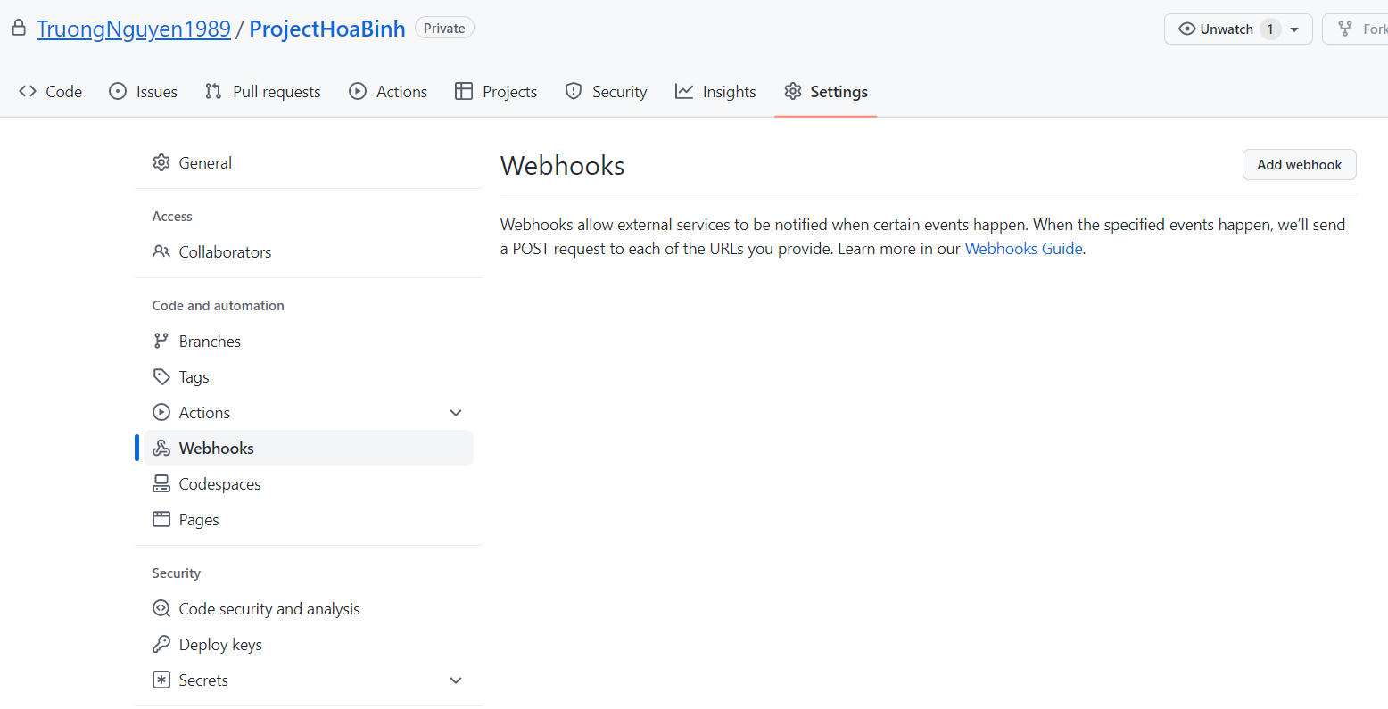

**Step 3:** In the ‘**Payload URL**’ field, paste your Jenkins environment URL. At the end of this URL add /github-webhook/. In the ‘**Content type**’ select: ‘application/json’ and leave the ‘**Secret**’ field empty.

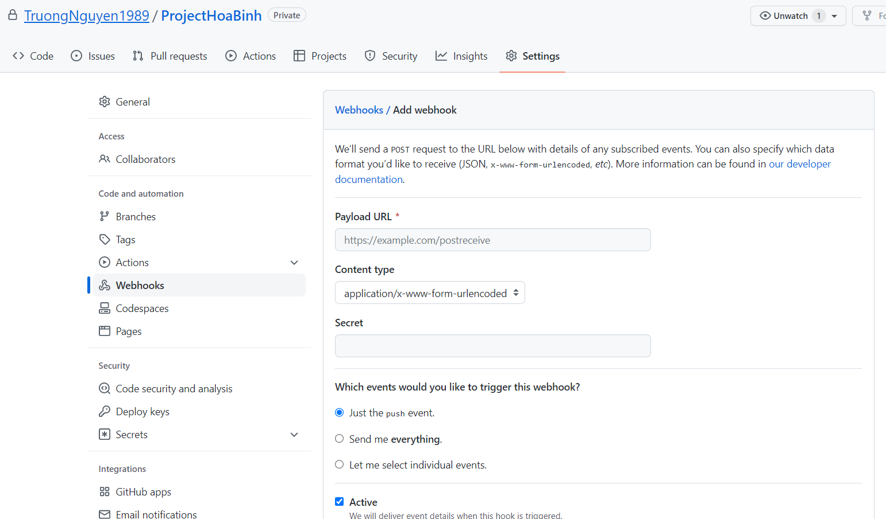

**Note:**

Payload URL Ex: <http://jenkins-demo.oryza.vn:8080/github-webhook/>

Content type: application.json

**Step 4:** In the page ‘**Which events would you like to trigger this webhook?**’ choose ‘**Let me select individual events.**’ Then, check ‘**Pull Requests**’ and ‘**Pushes**’. At the end of this option, make sure that the ‘**Active**’ option is checked and click on ‘**Add webhook**’.

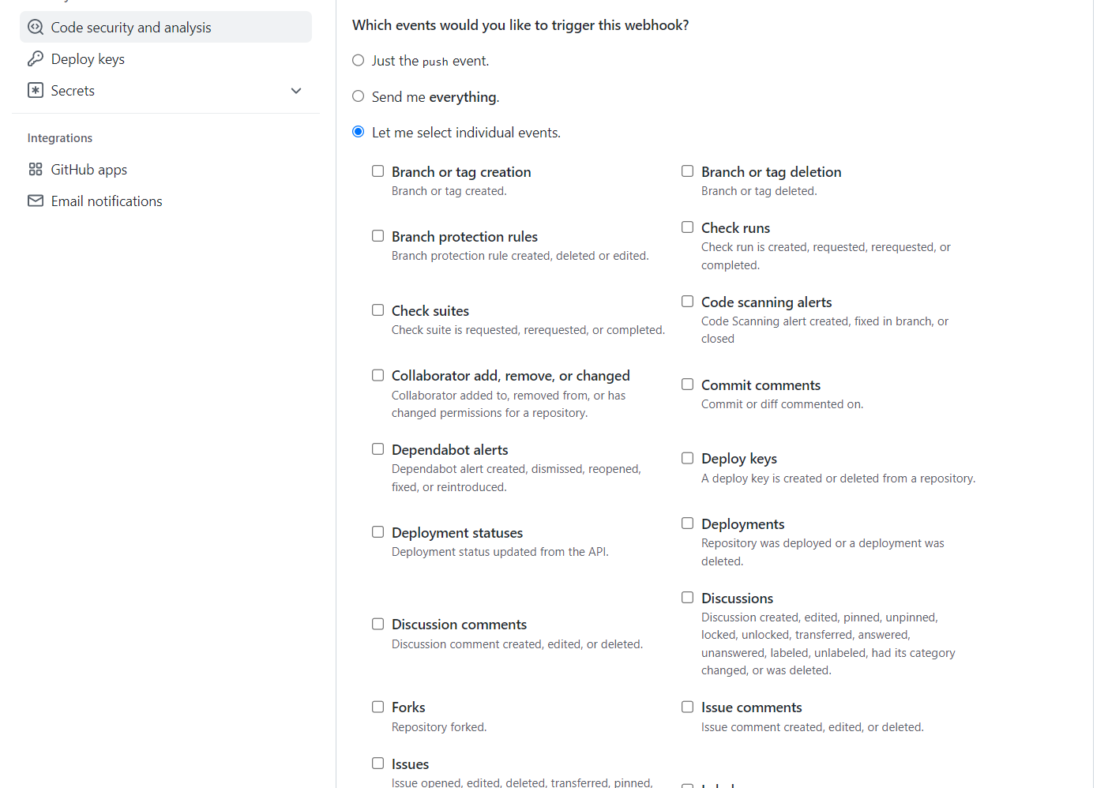

We're done with the configuration on GitHub’s side! Now let's move on to Jenkins.

**Configuring Jenkins**

**Step 5:** In Jenkins, click on ‘**New Item**’ to create a new project.

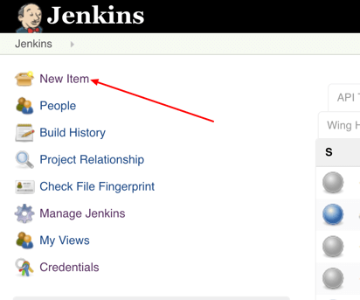

**Step 6:** Give your project a name, then choose ‘**Freestyle project**’ and finally, click on ‘**OK**’.

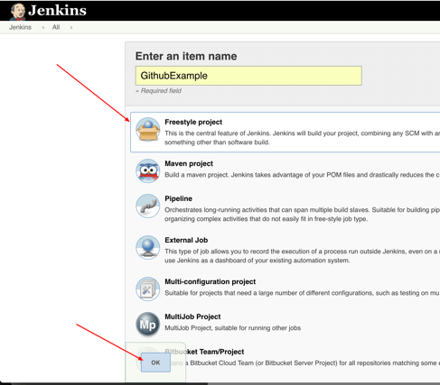

**Step 7:** Click on the ‘**Source Code Management**’ tab.

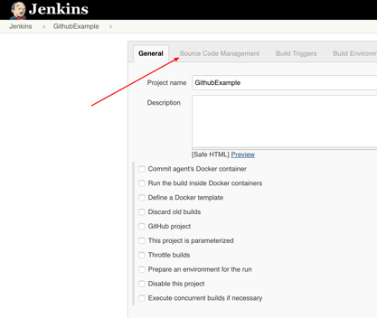

**Step 8:** Click on Git and paste your GitHub repository URL in the ‘**Repository URL**’ field.

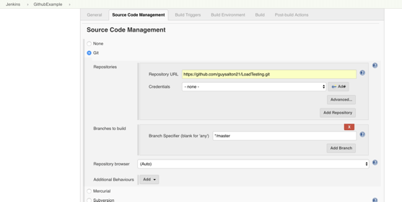

**Step 9:** Click on the ‘**Build Triggers**’ tab and then on the ‘**GitHub hook trigger for GITScm polling**’. Or, choose the trigger of your choice.

**Triggering the Jenkins GitHub Integration With Every Code Commit**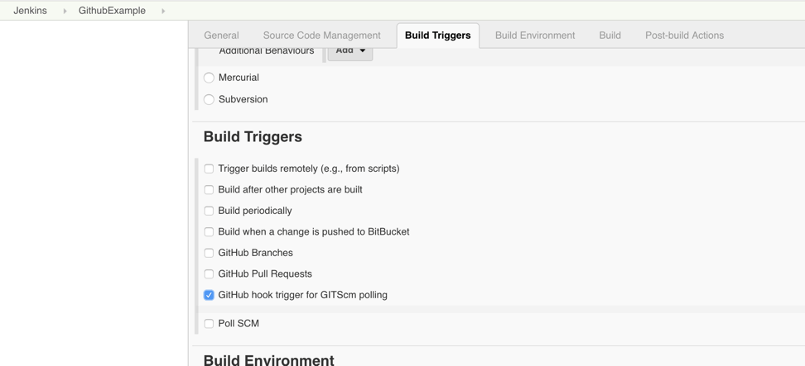

**Step 10:** Click on the ‘**Build**’ tab, then click on ‘**Add build step**’ and choose ‘**Execute shell**’.

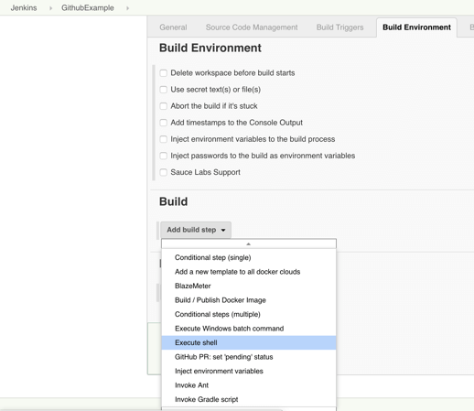

**Step 11:** To run a Taurus test, simply use the ‘**bzt’** command, followed by the name of your YML file and click on ‘**Save’**.

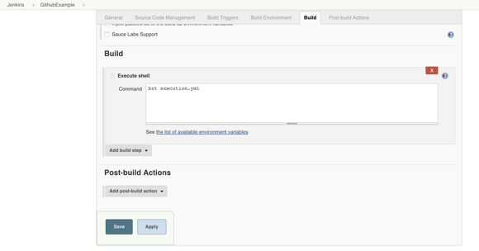

**Step 12:** Go back to your GitHub repository, edit the Taurus script and commit the changes. We will now see how Jenkins ran the script after the commit.

See more YAML: <https://www.tutorialspoint.com/yaml/index.htm>

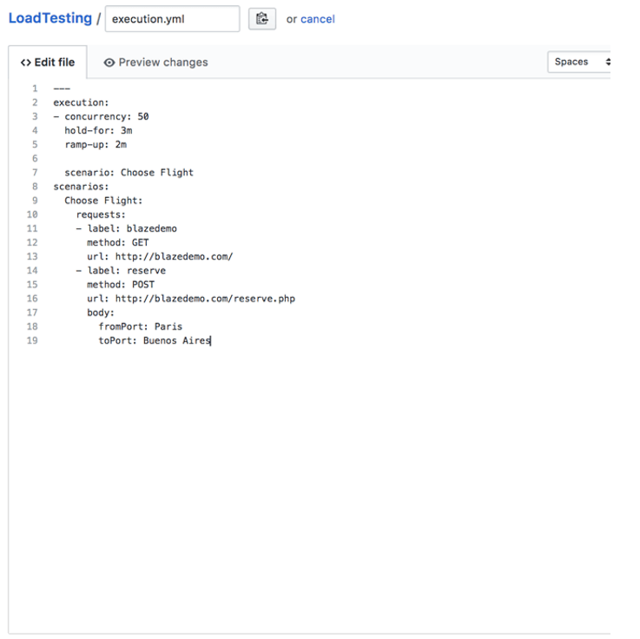

**Step 13:** Go back to your Jenkins project and you'll see that a new job was triggered automatically from the commit we made at the previous step. Click on the little arrow next to the job and choose ‘**Console Output**’.

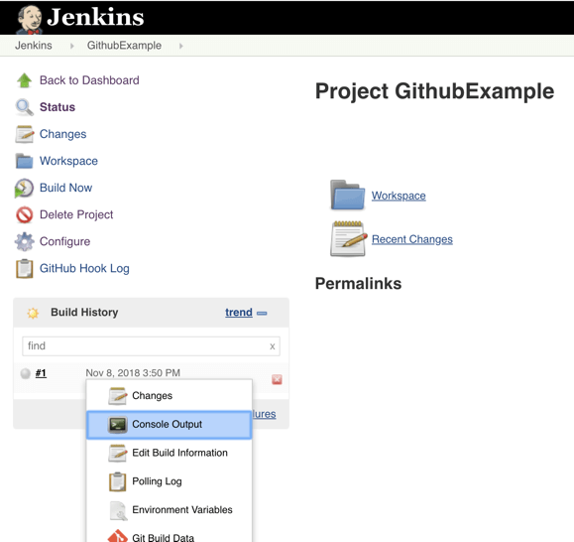

**Step 14:** You can see that Jenkins was able to pull the Taurus script and run it!

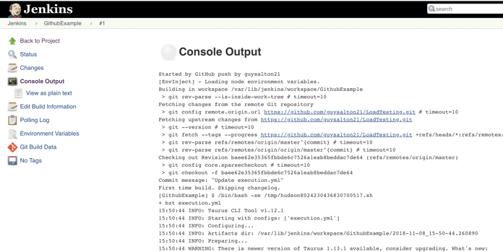

**Goodluck**